CSyllabus

Final Report

Version 0.1

Contents

1. *Introduction* 1

1.1 Purpose of this document 1

1.2 Document organization 1

1.3 Intended Audience 1

1.4 Scope 1

1.5 Definitions and acronyms 1

1.5.1 Definitions 1

1.5.2 Acronyms and abbreviations 2

1.6 References 2

2.1 Deliverables 2

2.2 Requirements document 2

2.3 Possible improvements 2

2.4 Software setup 2

2.5 Code structure 2

3.1 Organization and routines 3

3.2 Metrics 3

3.2.1 Project effort 3

3.2.2 Team metrics 3

3.3 Positive experiences 3

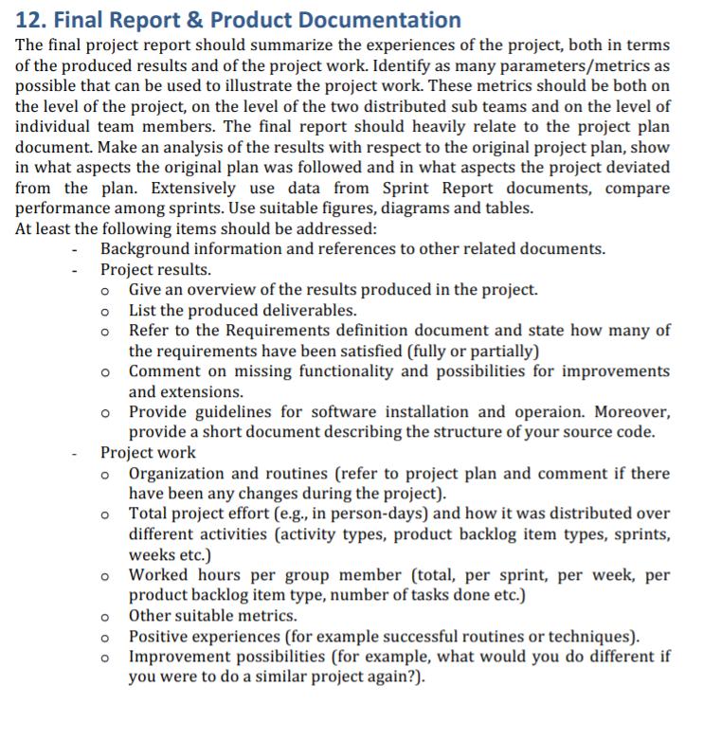

# Introduction

## Purpose of this document

## Document organization

The document is organized as follows:

* Section 1, *Introduction,* describes contents of this guide and provide general information’s for whom and in a what way is this document created
* Section 2, *Project results*
* Section 3, *Project work,*

## Intended Audience

The intended audience is:

* Project team
* Customer
* Product owner

## Scope

## Definitions and acronyms

### Definitions

|  |  |
| --- | --- |
| **Keyword** | **Definitions** |
| FER | Faculty of electrical engineering and computing |
|  |  |

### Acronyms and abbreviations

|  |  |
| --- | --- |
| **Acronym or**  **abbreviation** | **Definitions** |
| **NTR** | Nothing to Report.  There is no available information’s to a specific topic. |
| **US[x]** | User story with number **#X** from Requirements definition document. |

## References

This document refers to the

* Project Plan,
* Requirements and
* Design Description document.

1. Project results

-refer to requirements document

## Deliverables

## Requirements document

## Possible improvements

## Software setup

## Code structure

1. Project work

## Organization and routines

## Metrics

### Project effort

### Team metrics

#### Italy

#### Croatia

#### Individual team members

## Positive experiences